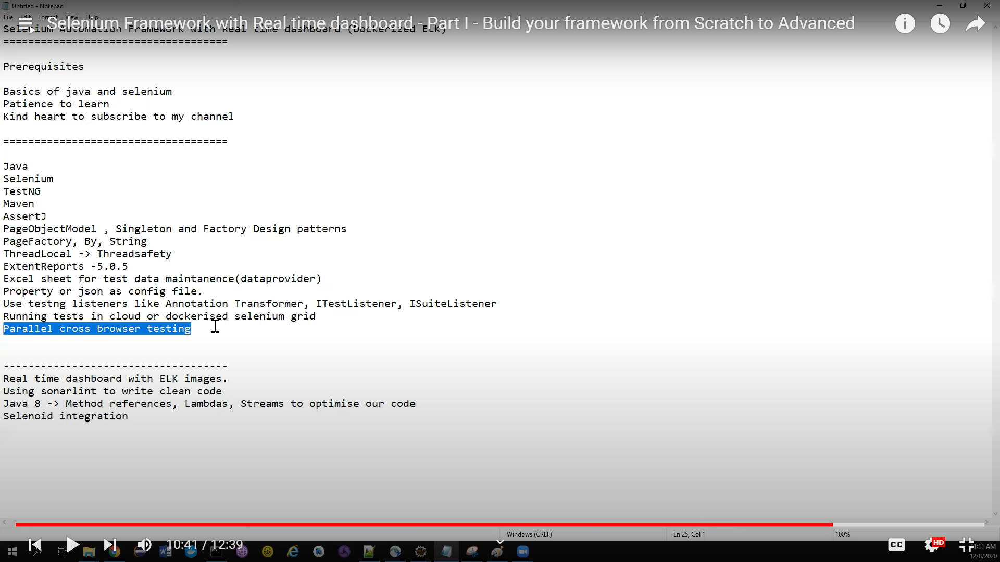

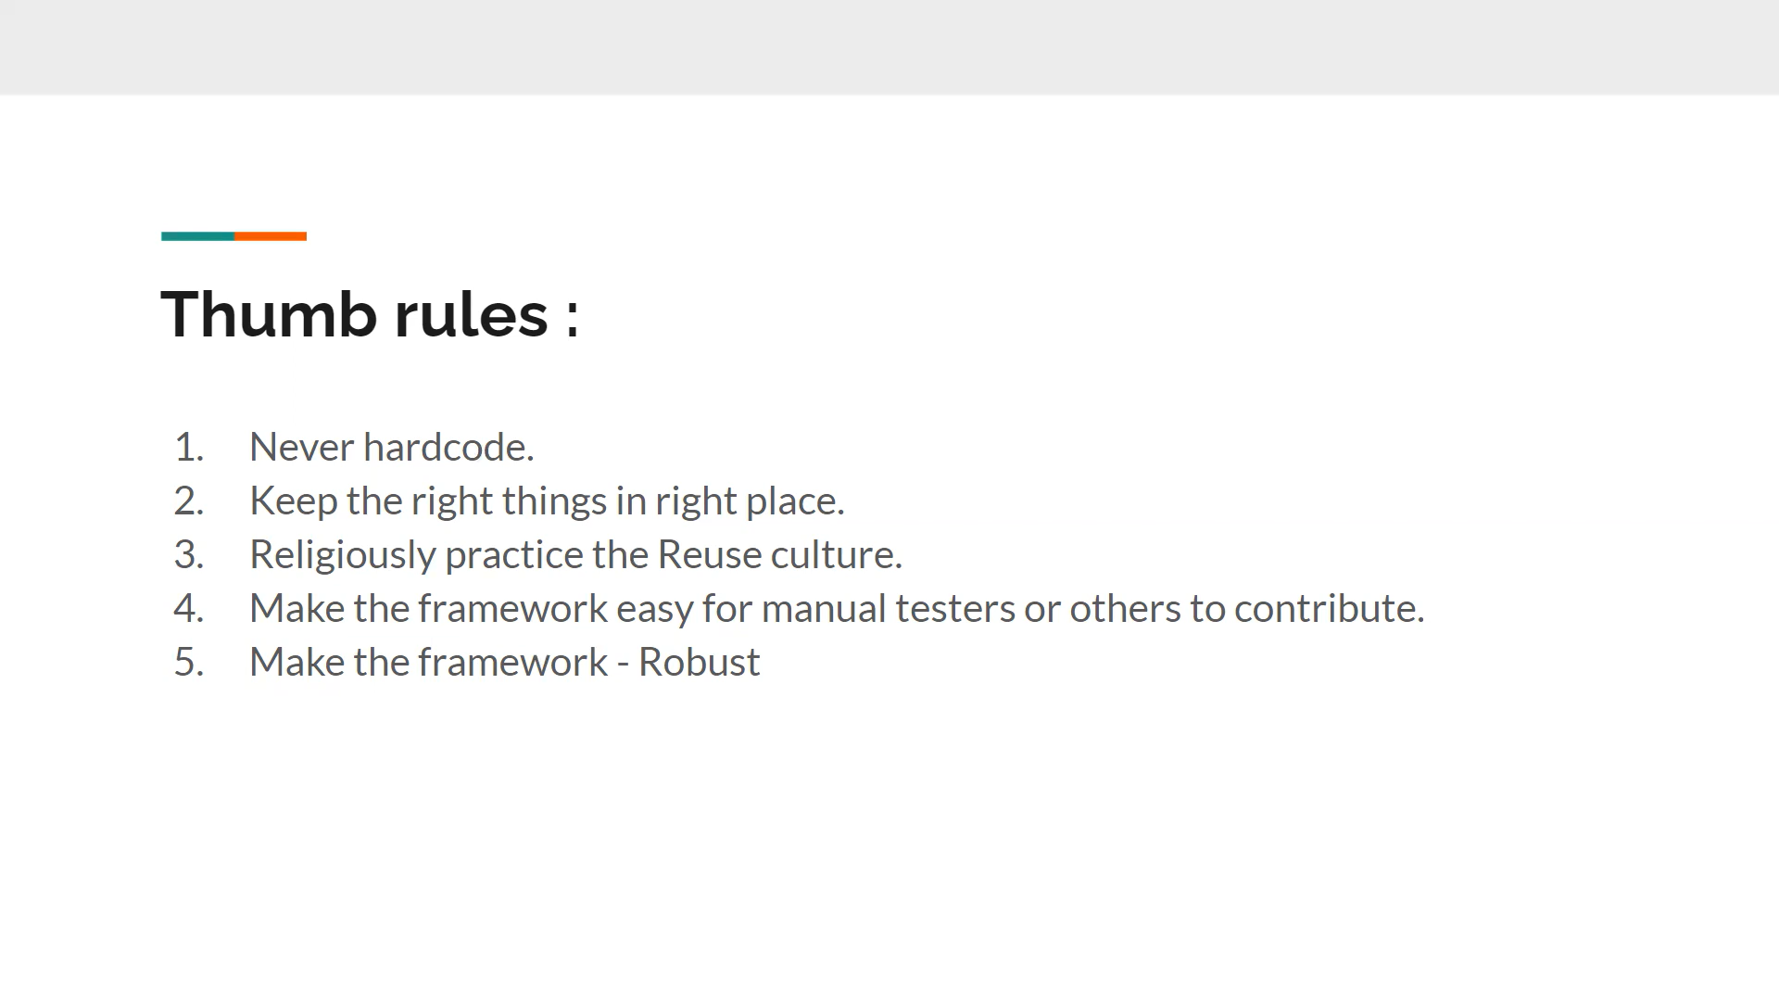

// naming conventions

//class or Interface name --> AnandPerumal

//final constant values -->ANANDPERUMAL or ANAND_PERUMAL

//method name -->camelcasing-->anandPerumal

//package name -->anandperumal